[- Space walk sequencing – 10 activities using different code styles.
Background to have a space look like below
Characters- Astronaut, Space ship & rocks

Story line here will be – Astronaut will have to reach the space ships crossing all rocks on his way and he will use different combinations of codes using commands to reach the space ship
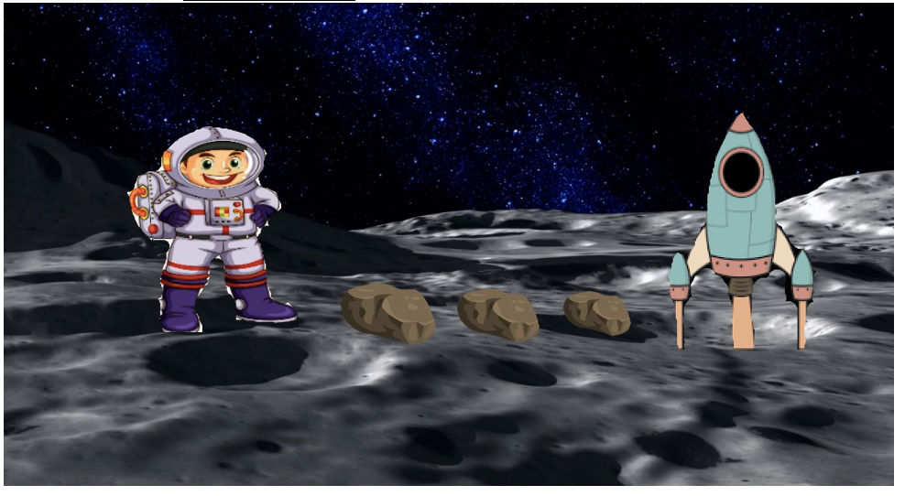
Different codes to be used –
Move forward

Jump

Jump & Shake

- I am adding answer in the box for 1st and 2nd activity.

1st code activity – Move forward / Move forward/ Jump/ Move forward
Block area (Where children will drag all code below as shown in the box )

Commands area

2nd code activity- Jump/ Jump/ Jump/ move forward
Block area (Where children will drag all code below as shown in the box )

Commands area

3rd code activity- jump & Shake/ move forward/ move forward/ jump
Block area (Where children will drag all code below as shown in the box )

Commands area

4th code activity- jump & shake/ Jumps & Shake/ jump & shake/ move forward
Block area (Where children will drag all code below as shown in the box )

Commands area

5th code activity- move forward/ jump/ jump & shake/ move forward
Block area (Where children will drag all code below as shown in the box )

Commands area

6th code activity- move forward/ jump/ jump / move forward
Block area (Where children will drag all code below as shown in the box )

Commands area

7th code activity- move forward/ jump & shake/ move forward/move forward
Block area (Where children will drag all code below as shown in the box )

Commands area

8th code activity- jump/ jump & shake/ move forward/move forward
Block area (Where children will drag all code below as shown in the box )

Commands area

9th code activity- move forward/ jump & shake/ move forward/jump
Block area (Where children will drag all code below as shown in the box )

Commands area

10th code activity- move forward/ jump/ jump / move forward
Block area (Where children will drag all code below as shown in the box )

Commands area

